University College London

Division of Surgery and Interventional Science

3rd Year Research Project Report, 2023-2024

Project title: **Can antibiotic modulate the immune system in sepsis?**

Student number: **21073148**

Candidate Number:  **KCVX3**

Module: **SURG0161**

# ABSTRACT

Sepsis is the dysregulated host response to an infection. Alongside supportive care, the sepsis treatment are antibiotics and managing the source of infection. It is shown that antibiotics influence the immune system, but their specific effects during sepsis remain unclear. I hypothesise that antibiotics directly impact immune cell function, potentially worsening immunosuppression in sepsis, particularly with broad-spectrum antibiotics.

We examine how both narrow- and broad-spectrum beta-lactam antibiotics affect immune function *in vivo* using peripheral blood mononuclear cells (PBMCs) isolated from patients attending the emergency department (ED) with infections.

PBMCs were treated *ex vivo* with Lipopolysaccharide (LPS) to evaluate monocyte function over 24 hours, and CD3/CD8 beads to evaluate CD4 lymphocyte function over 72 hours. These stimuli were applied both with and without the antibiotics Cefuroxime and Meropenem at clinically relevant low and high concentrations. The expression of standard functional markers on classical monocytes and CD4+ T lymphocytes was analysed using flow cytometry. Cell populations were identified using a Boolean gating strategy, selecting lymphocytes or PBMCs, single cells, viable cells, and specific cell markers. Fluorescence Minus One (FMO) controls were used to guide cell population gating for all fluorophores.

Cefuroxime and Meropenem are associated with anti-inflammatory changes including downregulation of monocyte class II-associated invariant chain peptides (CLIP), and CD14. Additionally, Meropenem resulted in a reduction in monocyte HLA-DR and NOX-2. CD4 lymphocyte CTLA-4 expression was increased with an associated reduction in cell proliferation. Additionally, Cefuroxime was associated with an increase in anti-inflammatory cytokines IL-4 and IL-10. In conclusion, beta-lactam antibiotics exacerbated features of sepsis-induced immunosuppression in monocytes and CD4 lymphocytes *ex vivo*. At higher doses, this might become more profound. Further research is required to determine the clinical implications.

Table of Contents

ABSTRACT 1

LIST OF ABBREVIATIONS 3

1. INTRODUCTION 5

1. 1 Immune System 5

1. 2 Immune Dysfunction in Sepsis 6

1.3 Antibiotics and immunity 7

1.4 Aims and Hypothesis 8

2. MATERIALS AND METHODS 9

2.1 Ethics 9

2.2 Product 9

2.3 Methods 9

3. RESULTS 14

4. DISCUSSION 18

4.1 Limitations and Future work 25

CONCLUSION 25

ACKNOWLEDGEMENTS 26

REFERENCES 27

APPENDIX A 33

# LIST OF ABBREVIATIONS

**Areg** - Amphiregulin

**CCR2** - C-C chemokine receptor type 2

**CD127** - Cluster of Differentiation 127 (Interleukin-7 receptor alpha)

**CD152** - Cluster of Differentiation 152 (Cytotoxic T-Lymphocyte-Associated Protein 4, CTLA-4)

**CD194** - Cluster of Differentiation 194 (Chemokine receptor, CCR4)

**CD196** - Cluster of Differentiation 196 (Chemokine receptor, CCR6)

**CD274** - Cluster of Differentiation 274 (Programmed death-ligand 1, PD-L1)

**CD274** - Cluster of Differentiation 274 (Programmed death-ligand 1, PD-L1)

**CD279** - Cluster of Differentiation 279 (Programmed cell death protein 1, PD-1)

**CD28** - Cluster of Differentiation 28

**CD284** - Cluster of Differentiation 284

**CD3** - Cluster of Differentiation 3

**CD4** - Cluster of Differentiation 4

**CD64** - Cluster of Differentiation 64

**CD74** - Cluster of Differentiation 74 (Invariant chain, Ii)

**CD80** - Cluster of Differentiation 80 (B7-1)

**CD95** - Cluster of Differentiation 95 (Fas receptor)

**CIITA** - Class II Major Histocompatibility Complex Transactivator

**EGFR** - Epidermal Growth Factor Receptor

**FOX-3** - Forkhead box P3 (commonly known as FOXP3)

**HLA-DM** - Human Leukocyte Antigen - DM isotype

**HLA-DP** - Human Leukocyte Antigen - DP isotype

**HLA-DR** - Human Leukocyte Antigen - DR isotype

**IFN-y** - Interferon gamma

**IL-10** - Interleukin-10

**IL-17a** - Interleukin-17a

**IL-1b** - Interleukin-1 beta

**IL-2** - Interleukin-2

**IL-4** - Interleukin-4

**MHC I** - Major Histocompatibility Complex class I

**MHC II** - Major Histocompatibility Complex class II

**NF-kB** - Nuclear Factor kappa-light-chain-enhancer of activated B cells

**NLRP3** - NOD-like receptor thermal protein domain associated protein 3

**NOX-2** - NADPH oxidase 2

**STAT5** - Signal Transducer and Activator of Transcription 5

**T-bet** - T-box expressed in T cells (officially known as TBX21)

**Th1** - T helper type 1 cells

**Th1** - T helper type 1 cells

**TLR4** - Toll-like receptor 4

**TNF-a** - Tumour Necrosis Factor alpha

# INTRODUCTION

Sepsis is a major health care burden with the mortality rate is high (between 15% and 20%), and >40% increase in the risk of death especially with gram-negative bacteria (Breijyeh, Jubeh and Karaman, 2020). The infection triggers both innate and adaptive response. This affects the level of immunoregulatory molecules, and effector immune cells, resulting in tissue damage. Although one of the main treatments of sepsis are antibiotics, it was revealed to cause side effects, and worsen the condition of sepsis-induced immunosuppression. In parallel, The World Health Organisation (WHO) has declared antimicrobial resistance (AMR) a global health emergency, making medications for treating infection less effective, which could result in 10 million deaths per year.

### 1. 1 Immune System

The immune system consists of innate and adaptive components that work together to provide defence against pathogens. Innate immunity, the initial line of defence, is rapid and non-specific. The adaptive immune response is a more specific and long defence against pathogens.

The innate immune system is activated when pattern recognition receptors (PRRs) on immune cells detect pathogen-associated molecular patterns (PAMPs) from microbes and damage-associated molecular patterns (DAMPs) released during tissue damage (Christophides et al., 2002). This activation triggers the production of pro-inflammatory cytokines and chemokines, leading to the recruitment of neutrophils and macrophages. Proteins like kinases and transcriptional regulators are subsequently activated, contributing to signal transduction pathways (García-Patiño, García-Contreras and Licona-Limón, 2017)(Christophides et al., 2002). After immune recognition, the effector response leads to pathogen elimination through phagocytosis. This induces the activation of antigen-presenting cells (APCs), such as macrophages, which present antigens via HLA class II molecules to helper T cells, initiating adaptive immune responses. Activated innate immune cells contribute to tissue inflammation by releasing pro-inflammatory mediators like TNF-a, IL-1, and IL-6, which can lead to the production of reactive oxygen species.

Alongside innate immune responses, tissue inflammation involves the infiltration of adaptive immune cells (Yi et al., 2019). Adaptive immune cells, including T and B lymphocytes, convey antigen-specific immune responses. T cells differentiate into effector T cells, producing pro- or anti-inflammatory cytokines, while B cells differentiate into plasma cells, generating specific antibodies (Sage et al., 2019)(Saigusa, Winkels and Ley, 2020). Adaptive immunity is highly specific, mediated by T and B cells. T cells engage in a multi-step response beginning with the interaction of T cell receptors (TCRs) with antigens presented by MHC complexes, followed by balancing signals from immunological checkpoints, which involve in stimulatory and inhibitory molecular pairs such as CD28/CD80-CD86 for stimulation and PD-1/PD-L1 for inhibition (Dai et al., 2017). Cytokine stimulation then promotes T cell proliferation and differentiation, enhancing cell activation (Dai et al., 2017) (Gerner et al., 2013). B cells works together with T cells with their ability to differentiate between self and non-self, ensuring recognition of foreign antigens over self-antigens. In collaboration with CD4+ T cells, B cells respond to various signals, including antigen recognition, immune checkpoints, and cytokine stimulation. Subsequently, B cells develop a memory capacity that allows for the recollection of past antigen encounters. This memory attribute significantly enhances future interactions, facilitating a more effective and rapid immune response (Althuwaiqeb and Bordoni, 2022).

### 1. 2 Immune Dysfunction in Sepsis

Sepsis is defined as life-threatening organ dysfunction caused by a dysregulated host response to infection. Septic shock is when profound circulatory and cellular abnormalities result in multiorgan failure (Singer, Deutschman and Seymour, 2016). Sepsis results in a failure to establish a balance between excessive and inadequate inflammation, causing severe organ damage and significant immunosuppression, which is an extreme inflammatory reaction to infection (Kovach and Standiford, 2012).

Initially, pathogen associated molecular pattern (PAMPs) from microorganisms is recognised by pattern recognition receptors (PRRs). PRR activation induces the gene transcription, and increases the synthesis and release of pro- and anti-inflammatory mediators, including cytokines by innate immune cells (neutrophils and monocytes) (van der Poll et al., 2017). The proinflammatory cytokines can result in an excessive amount of inflammation known as a cytokine storm, which may cause hypotension and organ failure (Boekstegers et al., 1991). This triggers a simultaneous anti-inflammatory reaction, releasing cytokines such as IL-10. This appears to cause a decrease in chemotaxis, and an increase in apoptosis of peripheral blood mononuclear cells (PBMCs) and splenocytes, resulting in immunosuppression. This leads to a decrease in chemotaxis, and an increase in apoptosis PBMCs and splenocytes, causing immunosuppression that affect both innate and adaptive responses (Boomer et al., 2011b). Additionally, CD4+ and CD8+ T-cell, B-cell and natural killer cells undergo increased apoptosis or exhaustion, further impairing effector and memory responses (Brady, Horie and Laffey, 2020).  This immunological impairment is characterised by the reduction of IFN-y and TNF-a by T cells and a rise in checkpoint regulators like PD-1, leading to diminished pro-inflammatory cytokine production (Hotchkiss et al., 2002). T-helper cell polarisation from a pro-inflammatory Th1 phenotype towards an anti-inflammatory Th2 phenotype also leads to immunosuppression (Clinical Laboratory int., 2020). Furthermore, decreased expression of HLA-DR, an important molecule for antigen presentation, along with diminished expression of co-stimulatory molecules such as CD80, contributes to impaired release of proinflammatory cytokines and reduced antigen-presenting capabilities. This results in lymphocyte anergy or death, thereby increasing the risk of nosocomial infections and mortality (Asalluah et al., 1995).

### 1.3 Antibiotics and immunity

The most commonly prescribed antimicrobials in the critically ill population include broad spectrum beta-lactams, particularly Meropenem, narrow-spectrum beta-lactams, Cephalosporins (particularly newer generations e.g. Cefortamine), Macrolides and Tetracyclines (Gonçalves-Pereira and Póvoa, 2011). Early and timely administration of appropriate antibiotics is crucial for improving the clinical outcomes of septic patients (Kumar et al., 2006)(Puskarich et al., 2011). In cases of septic shock, despite some conflicting evidence (Ryoo et al., 2015), any delay in treatment is linked to higher mortality rates and negative outcomes, including longer ICU stays and severe organ injuries, as measured by the Sepsis-Related Organ Assessment score (Rhodes et al., 2017). Furthermore, the correct dosage regimen are crucial for achieving clinical and microbiological success (Bloos et al., 2017).

There is a growing body of evidence supporting the immunomodulating effects of antibiotics, which may be either beneficial or harmful (Anderson et al., 2010). However, data on the immunomodulatory effect of beta-lactams in sepsis is limited, despite these being the most commonly used antibiotics and the highest risk population.

Our study focus particularly on the pathways involved in immunosuppression during sepsis as seen in figure 1. This includes monocyte antigen presentation and co-stimulation, such as CD80, CD86, and HLA-DR as well as immune checkpoint inhibition, including PD1 on lymphocytes and PD-L1 on monocytes. Additionally, we examined receptors related to lymphocyte proliferation and maturation, specifically the IL-2 and IL-7 receptors. Other areas of interest included lymphocyte activation markers CTLA-4 and CD28, and overall lymphocyte viability. Our comprehensive analysis also covered monocyte chemokine receptors, specifically CCR2 and CXCR4, and intracellular cytokines to provide a thorough understanding of the immune response in sepsis.

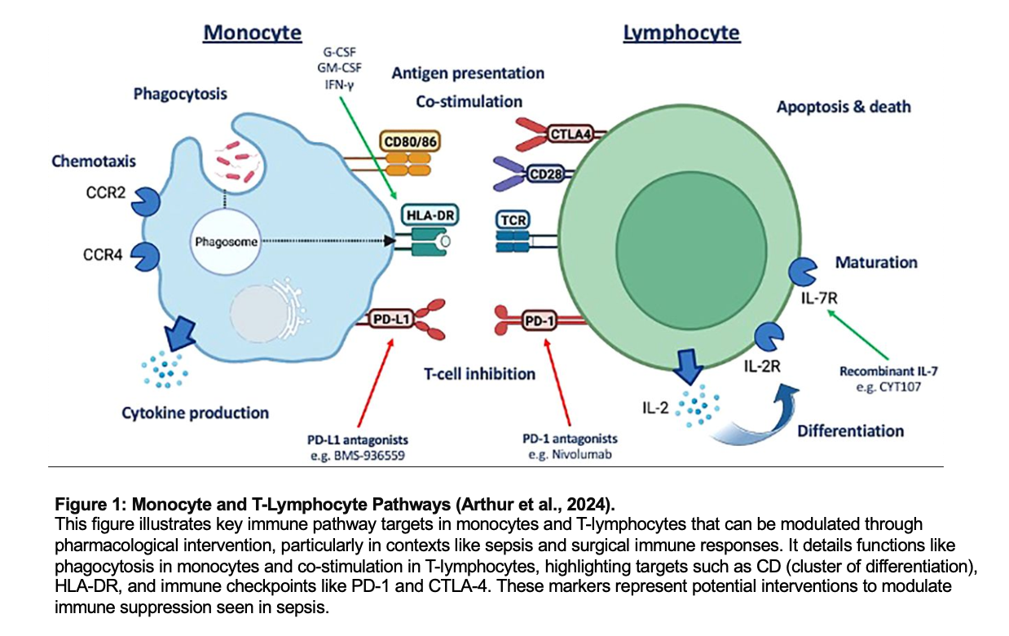

### 1.4 Aims and Hypothesis

I hypothesise that antibiotics have an off-target effect on immune cells, exacerbating immune dysfunction associated with sepsis; with broad-spectrum antibiotics having a greater effect.

My objective is to examine the *ex vivo* immunomodulatory effects of narrow and broad-spectrum beta-lactam antibiotics on peripheral blood mononuclear cells obtained from patients who attend the ER. We focused on assessing characteristics associated with sepsis- induced immune dysfunction.

# MATERIALS AND METHODS

Our study, conducted at University College London Hospital, included adults admitted to the emergency department with infections and healthy volunteers working in the university.

### 2.1 Ethics

The acquisition of clinical samples and data was obtained from Queen Square Research Ethics Committee provided ethical approval (REC reference 20/LO/1024). The ethics for obtaining healthy volunteer samples and data was provided by The University College London Research Ethics Committee (REC reference 19181/001).

### 2.2 Product

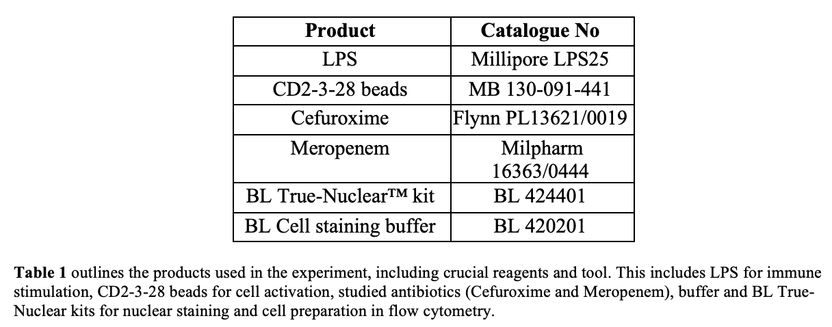

### 2.3 Methods

**2.3.1 Defrosting stored PBMCs**

PBMCs are taken out of liquid nitrogen storage. At room temperature, 1 mL of culture Roswell Park Memorial Institute medium (RPMI) was transferred to the cryopreserved PBMCs and pipetted to suspend the PBMCs. Upon partial thawing, the liquid was transferred into 10mL medium in a falcon tube mixed until samples were completely thawed. The cells were then centrifuged at 400 g for 5 minutes. After centrifugation, supernatant was discarded. Cells pellets were resuspended in 2.5 ml media to remove dimethyl sulfoxide found in the cryopreserved liquid/solution (Honge et al., 2017). Cells were centrifuged again and resuspended with 2 ml of RPMI media before resting at room temperature for 1 hour. Cells were then plated into a 96- well plate at 200 μL per well.

**2.3.2 Stimulation Of PBMC**

Meropenem and Cefuroxime were dissolved in water to create stock solutions before diluting with phosphate-buffered saline (PBS) to achieve working concentrations. Antibiotics were diluted to working concentrations in media and added to 96- well plates to achieve final desired concentrations. Lipopolysaccharide (100ng/mL) was used for monocyte stimulation (24hrs) and CD3-CD28 beads used for lymphocyte stimulation (72 hrs) in separate wells. The antibiotic-containing media (± LPS) was replaced every 24 hours.

**2.3.3 Cell Staining**

For cell staining following stimulation, cells were centrifuged (400 rcf, 5 min) and the supernatant is collected for ELISA. Cells are then resuspended in a 30µl/well cell staining buffer and labelled with a panel of antibodies tagged with various fluorochromes to detect specific surface markers on monocytes and lymphocytes. After incubation at room temperature for 30 minutes, cells were centrifuged and washed with a staining buffer, followed by resuspended in 50µl/well with Nuclearfix, stopping cell process. Next, cells are incubated at 4°C for 45 mins, followed by centrifugation. They are then resuspended in 30µl/well with Nuclearperm, a permeabilization solution, allowing antibodies to stain for cytokines and pass through the cell. After a final incubation at 4°C for 40 minutes and subsequent centrifugation, the cells are resuspended in a staining buffer (Rodig, 2022). This method ensures both surface and intracellular markers are adequately labelled for subsequent detection and quantification by flow cytometry. Details of products and concentrations used are provided in table 2.

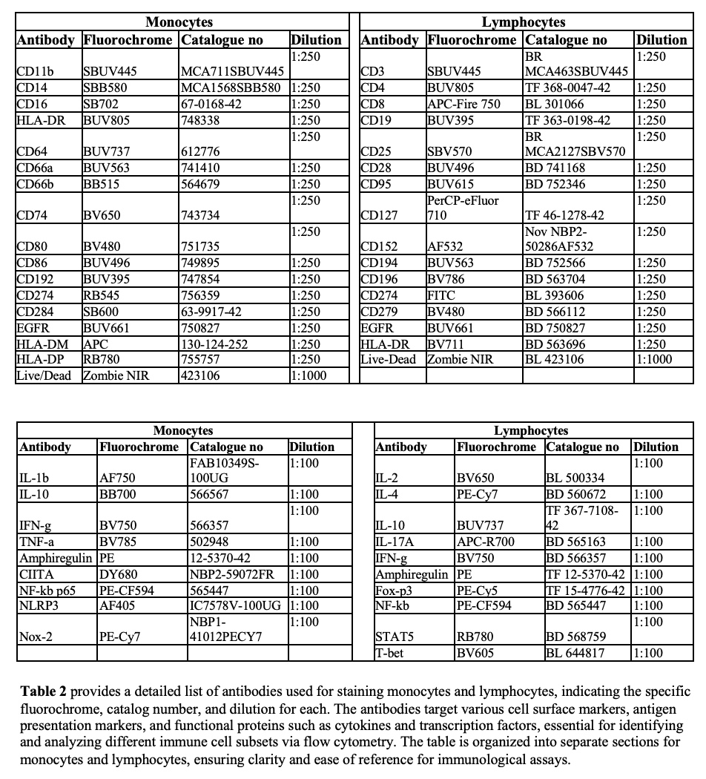

**2.3.4 Analysis**

Cells were acquired on the Sony ID7000 spectral flow cytometer. Compensation controls were applied to all samples prior to analysis. Compensation was established using single-stained controls with BD Biosciences beads or cells stained with Live/Dead markers to adjust for spectral overlap between fluorochromes, ensuring channel-specific fluorescence detection. Fluorescence Minus One (FMO) samples for all fluorophores were run to guide gating of cell populations. This is to determine the boundary between negative and positive populations in multicolour flow cytometry panels. Cell populations of interest were identified using the following Boolean gating strategy which included the selection of lymphocytes or PBMCs, single cells, viable cells, and specific cell surface markers.

Differences in cytokine production and phenotypic expression between sepsis and non-sepsis were analysed using a two-tailed nonparametric Mann-Whitney U test with GraphPad Prism. Statistical significance was set at p ≤ 0.05. The mean fluorescence intensity (MFI) of each marker is converted to MESF units using the Quantum Bead MESF standard curve. Running Quantum MESF beads simultaneously with subject samples on the same flow cytometer allows for direct comparison across different subjects and times. The data are shown as median interquartile ranges or percentages counts. Flow cytometry results are displayed in percentage of positive cells, including interquartile range, as illustrated in figure 1.

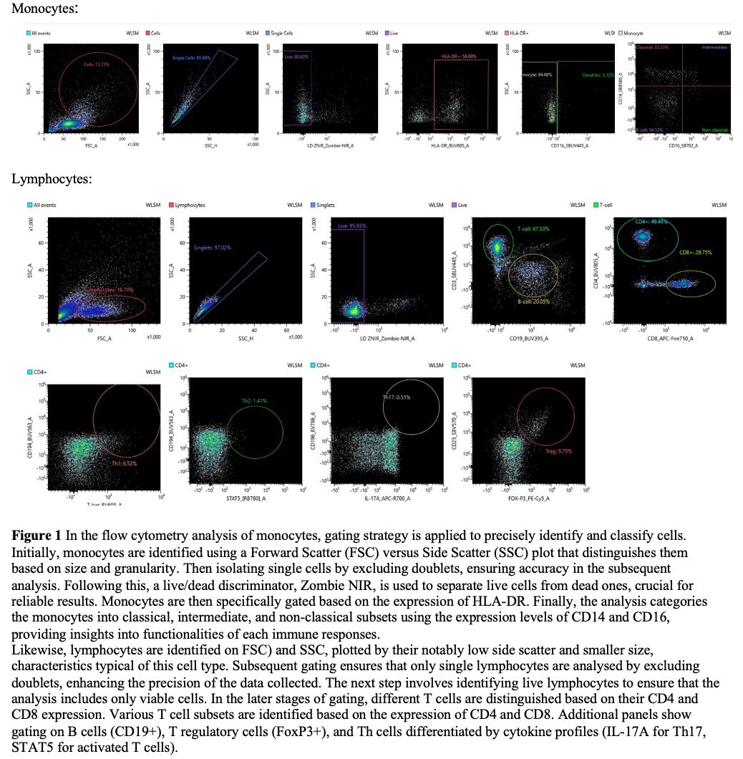

# 

# RESULTS

Twelve patients with sepsis and 4 healthy volunteers were examined. Percentage changes in cell phenotype percentages are presented in figures 3 and 4. These figures illustrate the expression patterns of specific cell markers, which have shown significant differences between groups.

* 1. **Monocyte Stimulation**

Ctrl vs LPS

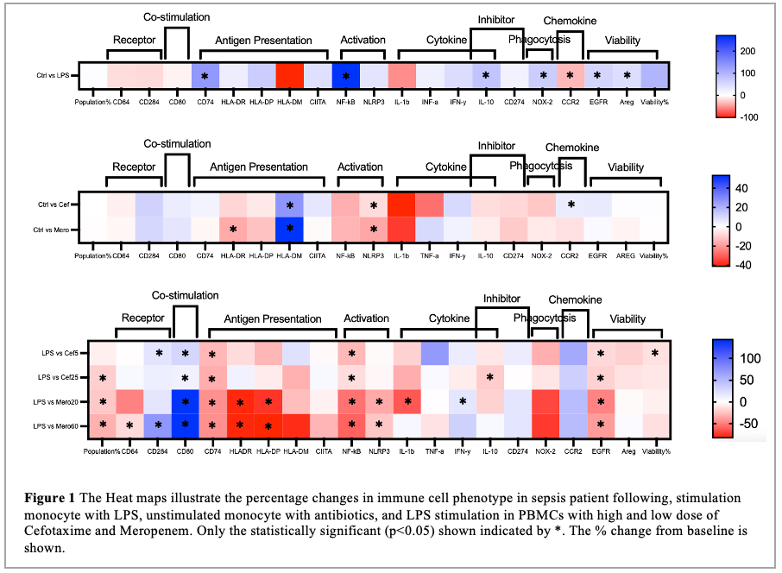

Abx vs LPS

Ctrl vs Abx

**3.1.1 Effect of LPS on Monocytes (Ctrl vs LPS)**

Stimulation of monocyte with LPS resulted in a statistically significant increase in markers associated with antigen presentation (CD74; p=0.0078 and CIITA; p=0.0574). There was an upregulation in activation, NF-kB (p=0.0234). Likewise, there was an increase in intracellular cytokines, IFN-y (p=0.0574) and IL-10 p=0.0391), oxidative burst capacity (NOX-2; p=0.0391) and cell viability (p=0.0005) (Figure 3, Supplementary Figure 5).

**3.1.2 Effect of Antibiotics on Unstimulated Monocytes (Ctrl vs Abx)**

Co-incubation of unstimulated PBMCs with high dose Cefuroxime only resulted in an increase in monocyte markers associated with antigen presentation and cytokine, which were HLA-DM (p=0.0124) and IFN-y (p=0.0801), respectively. Likewise, there was an increase in chemokine, CCR2 (p=0.0455) (Figure 3, Supplementary Figure 5).

Co-incubation of unstimulated PBMCs with high dose Meropenem resulted in an increase in monocyte in monocyte antigen presentation markers, HLA-DM (p=0.0455) although HLA-DR was lower (p=0.0244). There was a reduction in activation markers, including NF-kB (p=0.0608) and NLRP3 (p=0.0005). However, Meropenem increased the cytokine level in TNF-a (p=0.0801) (Figure 3, Supplementary Figure 5).

**3.1.3 Effect of Antibiotics on Stimulated Monocytes (LPS vs Abx)**

Co-incubation of PBMCs with Cefuroxime resulted in lower in markers associated with cell viability in low and high dose (EGFR; p=0.0801, p=0.0175, respectively); however, percentage viability (p=0.0412) albeit only at low dose. At both the low and high doses, markers associated with antigen presentation, specifically CD74, were reduced (p=0.0027 and p=0.0244, respectively). Similarly, the activation marker NF-kB also showed reductions (p=0.0455 at the low dose and p=0.0601 at the high dose) (Figure 3, Supplementary Figure 6).

Co -stimulatory marker CD80 increased at low and high dose (p=0.0060 and p=0.0801 respectively). The cell surface receptor, CD284 (p=0.0455) also upregulated at low dose.

Co-incubation of PBMCs with Meropenem was associated with an increase in CD284 (p=0.0027 at high dose), co-stimulatory marker CD80 (p=0.0124 and p=0.0005 at low and high dose respectively), and IFN-y at low dose only (p=0.0801). CD64 (p=0.0080 at high dose), IL-1b (p=0.0801 at low dose), HLA-DR (p=0.0124 and p=0.0005 at low and high dose respectively), HLA-DP(p=0.0124 and p=0.0060 at low and high dose respectively), NF-kB (p=0.0064 and p=0.0124 at low and high dose respectively), NLRP3 (p=0.0610 and p=0.0450,at low and high dose respectively), and EGFR (p=0.0027 and p=0.024 at low and high dose respectively) were significantly reduced with meropenem co-incubation (Figure 3, Supplementary Figure 7).

**3.2 CD4+ T Lymphocytes Stimulation**

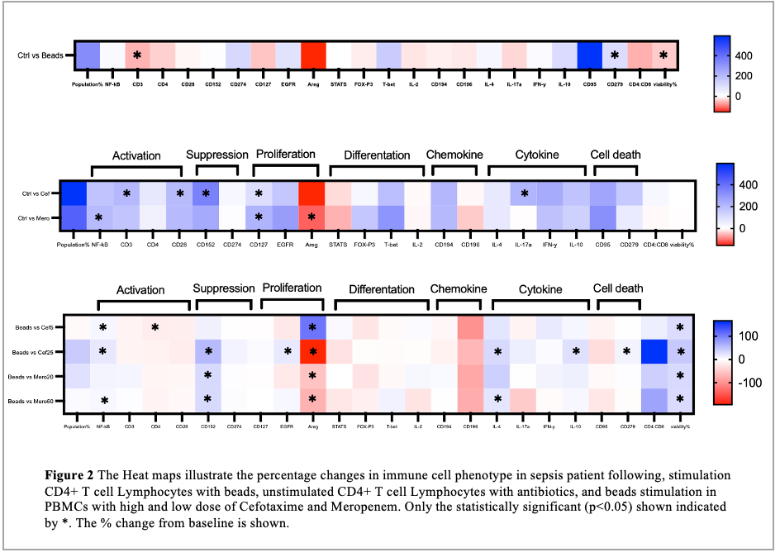

Ctrl vs Abx

Beads vs Abx

Ctrl vs Beads

**3.2.1 Effect of Beads on CD4+ T lymphocytes (Ctrl vs Beads)**

Following beads stimulation of lymphocytes, the cell viability increased (p=0.0420). There is a downregulation in activation markers, including CD3 (p=0.0039) and CD4 (p=0.0645). However, the stimulation was seen to increase the marker associated with cell death, CD279 (p=0.0245) (Figure 4, Supplementary Figure 8).

**3.2.2 Effect of Antibiotics on Unstimulated CD4+ T lymphocytes (Ctrl vs Abx)**

Co-incubation of unstimulated PBMCs with high dose Cefuroxime upregulated monocyte markers associated with antigen presentation, NF-kB (p=0.0736), CD3 (p=0.0253) and CD28 (p=0.0073). The level of suppression associated marker, CD152 (p=0.0017) also increased. Proliferation markers generally showed an upsurge, including CD127 (p=0.0253) and EGFR (p=0.0736), except for Areg (p=0.0073) in both antibiotics, which are notably suppressed. Cefuroxime also augment cytokine production, particularly evident with a significant rise in IL-17a (p=0.0037) and IL-10 levels (p=0.0736) (Figure 4, Supplementary Figure 8).

Co-incubation of unstimulated PBMCs with high dose Meropenem, caused an increase in the expression of activation markers, including NF-kB (p=0.0253), CD4 (p=0.0736) and CD28 (p=0.0073). Meropenum also showed an effect on the makers associated with proliferation. High dose of Meropenem increased CD127 (p=0.0001) but decreased Areg (p=0.0442). However, the expression wasn’t significant in suppression, differentiation, chemokine, cytokine and cell death (Figure 4, Supplementary Figure 8).

**3.2.3 Effect of Antibiotics on Stimulated CD4+ T lymphocytes (Beads vs Abx)**

Co-incubation of PBMCs with Cefuroxime resulted in an increase in viability in both low and high dose (p=0.003 and p=0.0330, respectively). Likewise, markers associated with activation NF-kB was upregulated in both dosages (p=0.0253 and p=0.0017 at low and high dose respectively). A dose-dependent increase in NF-kB was also observed. However, CD4 associated with activation was decreased in dose of Cefuroxime (p=0.0336). Additionally, there was a several changes in proliferation markers. At high dose, Cefuroxime decrease the expression of Areg (p=0.0017) but downregulated Areg at low dose (p=0.0253). There was also an increase in EGFR level (p=0.0442) with high dose of Cefuroxime. High dose of Cefuroxime was also seen to upregulate the expression of cytokine, IL-4 (p=0.0052) and IL-10 (p=0.0073). Lastly, CD279 (p=0.0588)associated with cell death was increased with high dose of of Cefuroxime (Figure 4, Supplementary Figure 9)..

Co-incubation of PBMCs with Meropenem was associated with an increase in viability in both low and high dose, similar to Cefuroxime (p=0.0003 and p=0.0330, respectively). Activation marker, NF-kB (p=0.0442) was increase in high dose Meropenum. Cytokine-related markers showed upregulation in high dose Meropenum, evidenced by raised levels of cytokines IL-4 (p=0.0442). Meropenum in both doses significantly increased CD152 expression. Additionally, Areg expression was lower with both low and high dose (p=0.0037, p=0.0017, respectively) (Figure 4, Supplementary Figure 10).

# DISCUSSION

The excessive inflammatory response in sepsis is mediated by several cytokines and signalling molecules. My results suggest that antibiotics could modulate the immune response in septic patients. There are immunomodulatory properties of different types of beta-lactams at different dosage. To date, studies comparing the effect of beta-lactam antibiotics on the immune response in sepsis are limited. Our finding addresses a key area in understanding the immunophenotype in sepsis patients highlighting that antibiotics can alter immune function

Lipopolysaccharide (LPS), a main component of the outer wall of gram-negative bacteria, triggers an immune response through the interaction with the LPS-binding protein. The interaction between LPS and its binding protein facilitated in its transfer to cell surface markers, CD14 and CD284 on monocytes, causing the release of inflammatory cytokines and upregulation of co-stimulatory molecules on antigen presenting cells (McAleer and Vella, 2008). Our study corroborates the findings, demonstrating that LPS stimulation could regulate production of proliferation markers in monocytes. We observed that with monocytes, LPS can induce TFN-y and IL-10 in prototypical inflammatory cytokine, involving in acute phase protein and cytokine production, cell proliferation, differentiation and adhesion molecule expression. IFN-y induces cytotoxic activities of T cell and natural killer cells, promoting expression of other inflammatory cytokines and chemokines in an early stage of sepsis. IL-10 acts as an anti-inflammatory cytokine, and counterbalances aggressive inflammatory response. The downregulation of markers associated with inflammation and chemotaxis CCR2, thus enhanced oxidative burst capacity and cytotoxic T cell, highlighted by increases in Nox-2 and CD279. Despite there is no effect of LPS to intracellular cytokine levels, the release of cytokine, such as TFN-y, INF-a, and IL-10 can modulate the function of CD4+ T cells. The future work will involve measurement of released cytokines.

The immune response against microorganism is dependent on monocytes and lymphocytes, specifically through expression of HLA-DR on monocytes for the T-cell receptor to specifically activate T cells. Previous studies show a reduction of the monocyte HLA-DR expression and a corresponding to inflammatory stimuli (Volk et al., 1991b). These findings were interpreted with the reduction in antigen presentation cell simultaneously with signs of hyperinflammation seen in early phase of severe sepsis. Our study explored this further as we were able to tell the dose-dependent modulation of immune markers with Meropenem, including reduction in antigen presentation components like HLA-DR, HLA-DP. Our finding addresses the limitation in understanding HLA-DR level changes in sepsis patients within critical care, clarifying that critical care alone does not significantly alter HLA-DR levels. Previous studies also confirmed that HLA-DR levels normalise within a week in uncomplicated trauma recoveries (Hershman et al., 1990).

        Sepsis treatments targeting proinflammatory cytokines like TNF-a and IL-6, have not resulted in decreased mortality (Franco, Chen and Pan, 2021). NF-kB plays a critical role in regulating apoptosis through oxidative stress, synthesising proapoptotic nitric oxide. In septic shock, higher NF-kB activity correlates with illness severity (Böhrer et al., 1997). Our findings demonstrate that antibiotics could increase the NF-kB expression in dose-dependent, potentially enhancing T cell response to inflammation. Sepsis activates the NLRP3 inflammasome, which mediates inflammation via cytokines like IL-1b and IL-18. Our findings reveal NLRP3 downregulation following antibiotic treatment. The upregulation of IFN-y and TNF-a in monocytes, potentially reversing immune paralysis in sepsis and enhancing macrophage intracellular killing (Flohé et al., 2008). These cytokines are key to fighting bacterial infections and initiating immune responses, with early TNF-a release activating immune cells and IL-1 from macrophages (Cohen et al., 2011). Furthermore, Meropenem was found to exhibit anti-inflammatory effects by decreasing IL-1b levels in monocytes, aligning with findings by Richard A (Zager, Johnson and Geballe, 2007). This suppression of pro-inflammatory cytokine responses suggests that beta-lactam antibiotics could modulate cytokine expression. The reduction in pro-inflammatory cytokines may be linked to impaired NF-kB phosphorylation, as indicated in stimulated monocytes and CD4+ T cells from sepsis patients (Cabrera-Perez et al., 2014).

 T cell exhaustion during chronic infections, driven by persistent antigen exposure, results in functional decline and increased expression of co-inhibitory receptors like CTLA-4 (CD152) and PD-1 (CD279). In sepsis, overexpression of PD-1 and PD-L1 correlates with higher mortality and more hospital-acquired infections, while negatively impacting lymphocyte proliferation (Monneret and Venet, 2015). Our study found that CTLA-4 expression on lymphocytes rises during the first week of sepsis post-antibiotic treatment, highlighting the potential of anti-CTLA-4 blocking antibodies to enhance immune response in sepsis treatment. Accordingly, the antibiotics upregulated the expression of NF-kB, which is notably activated in sepsis (Liu and Malik, 2006). However, Cefuroxime suppressed CD4 expression, which is crucial for the formation of functional CD8 T cell memory and mediating adaptive immune responses (Muñoz-Ruiz et al., 2013b). This finding supports previous studies that highlight the direct role of CD4 T cells in mediating the host response to sepsis (Kim et al., 2008). We detected an upregulation of the anti-inflammatory cytokine IL-10 in both monocytes and CD4+ T cells during sepsis. Increased IL-10 production from CD4+ T cells correlates with enhanced survival rates in sepsis. This rise in IL-10, particularly from CD4+ T cells, aligns with benefits observed in sepsis-treated animals using CD28 agonists, and plays a critical role in modulating immune responses by down-regulating HLA-DR (Thibodeau et al., 2008). Conversely, Cefuroxime suppresses CD4 expression, crucial for developing functional CD8 T cell memory and mediating adaptive immune responses, underscoring the direct impact of CD4 T cells in sepsis response.

Additionally, The CD4+/CD8+ ratio in T cells is a reliable measure of immune function. During sepsis, this ratio often decreases, which is closely associated with immunosuppression. Although Xia et al. found that sepsis patients have a significantly lower CD4+/CD8+ ratio compared to healthy patients, our result doesn’t show a significant change in ratio with antibiotics (Su Ji Jeong et al., 2014).

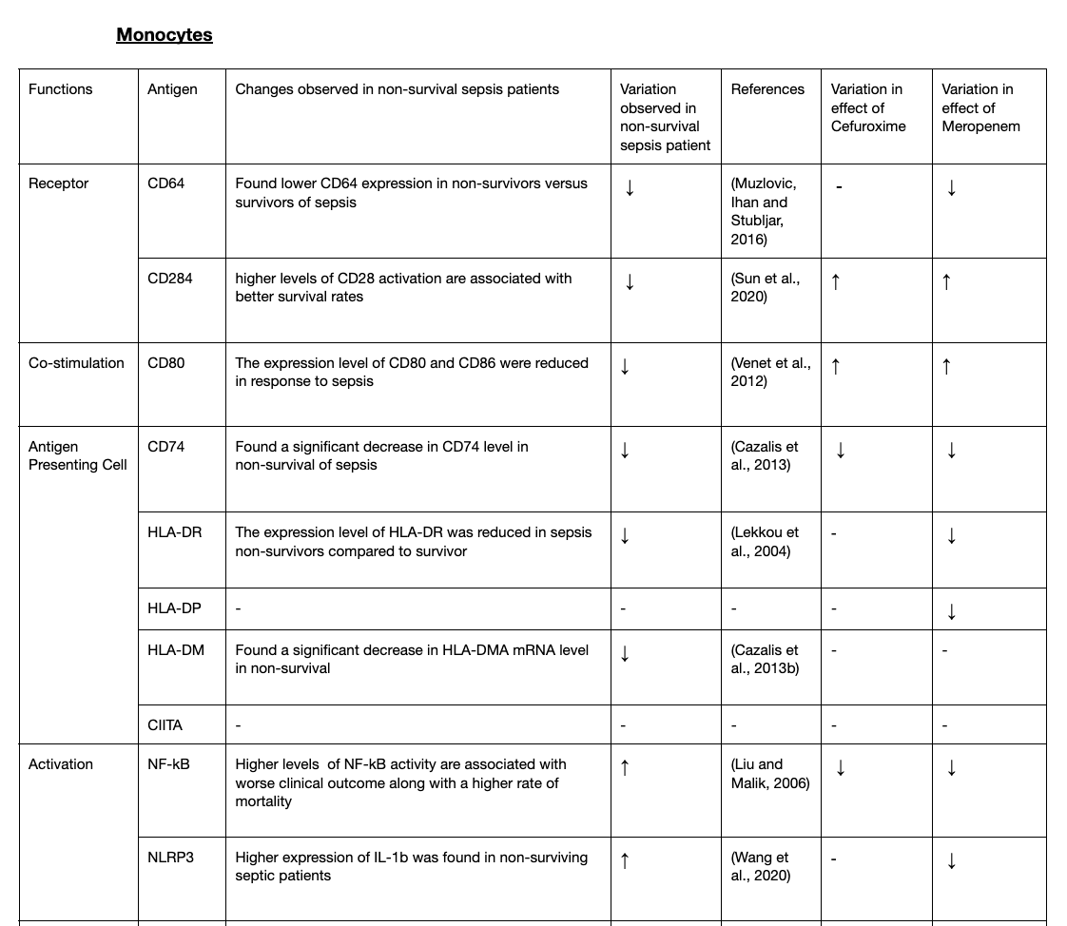**Monocytes**

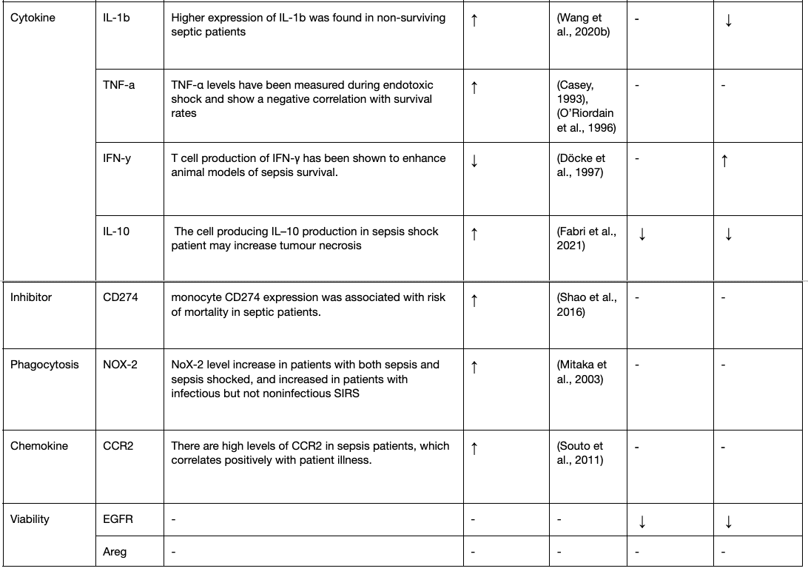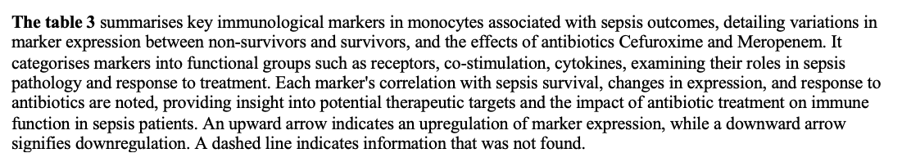

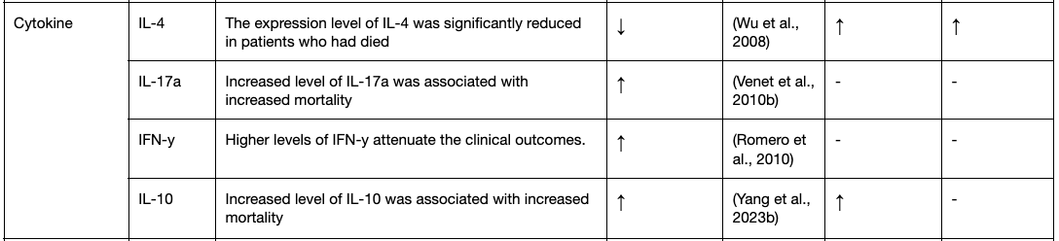**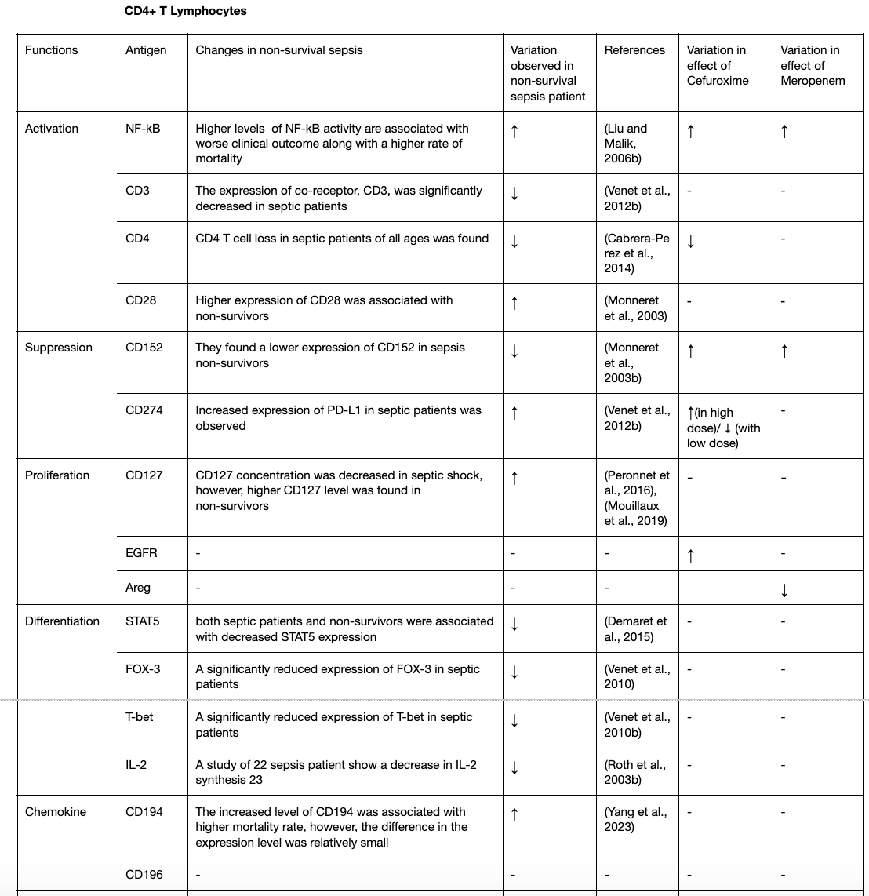CD4+ T Lymphocytes**

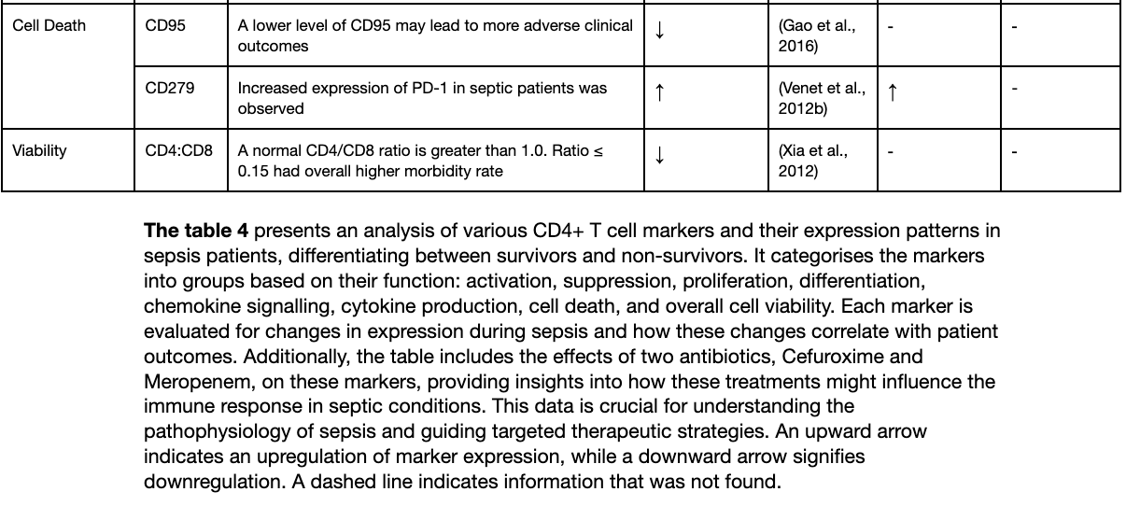

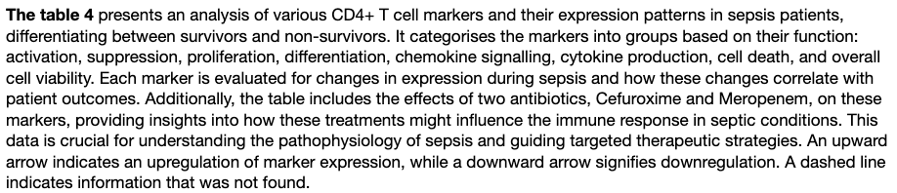

In monocytes, as seen in table 3, lower CD64 expression is observed in sepsis non-survivors (Muzlovic, Ihan and Stubljar, 2016), while higher levels of CD284 activation are associated with better survival outcomes (Sun et al., 2020). Our study indicates that Meropenem tends to decrease CD64 expression further, while both Cefuroxime and Meropenem enhance CD284 activation. Co-stimulation marker CD80, is lower in sepsis non-survivors (Venet et al., 2012), with both antibiotics tested showing a capability to counteract this reduction. This restoration of CD80 expression could enhance the immune response during sepsis, possibly aiding in the overall recovery process.

NF-kB; a crucial transcription factor that regulates immune and inflammatory responses, is higher in sepsis non-survivors. Antibiotics decrease NF-kB activity, which might be beneficial as excessive NF-kB activation can lead to uncontrolled inflammation and subsequent tissue damage, exacerbating sepsis conditions

NLRP3 and IL-1b are integral to the inflammatory response (inflammasome), with IL-1b being a pro-inflammatory cytokine that plays a pivotal role in mediating systemic inflammation. Studies have shown that higher expression levels of IL-1b are found in non-surviving septic patients, suggesting that an overproduction of IL-1b may contribute to adverse outcomes. Antibiotics reduce IL-1b levels, potentially curtailing the harmful overstimulation of the immune system and improving survival prospects. Conversely, TNF-a, another critical cytokine in the inflammatory cascade, is higher in sepsis non-survivors. Our data does not demonstrate an impact of antibiotics on TNF-a levels.

Furthermore, IFN-y and IL-10 represent contrasting aspects of the immune response. IFN-y, increased with the use of antibiotic, possibly enhancing survival in sepsis and is crucial for the activation of macrophages and other immune cells. On the other hand, IL-10, an anti-inflammatory cytokine, tends to increase in septic patients and can lead to an immunosuppressive state, potentially detrimental in fighting infections. Antibiotics reduce IL-10 production, which might be used to prevent excessive immune suppression and facilitating a more balanced immune response.

With regards to CD4+ T cell lymphocytes as shown in table 4, NF-kB activation is observed at higher levels in sepsis non-survivors, suggesting that an overactive NF-kB pathway may correlate with poorer outcomes (Liu and Malik, 2006b). However, Cefuroxime and Meropenem appear to increase NF-kB activity, possibly exacerbating inflammation.

CD4+ T cell loss is prevalent across all ages in septic patients. Cefuroxime appears to exacerbate this suppression, suggesting a detrimental effect of this antibiotic on CD4+ T cell populations during sepsis. Additionally, CD152 expression is lower in non-survivors (Monneret et al., 2003b), and both Cefuroxime and Meropenem increase its levels, potentially contributing to a lymphocyte anergy. In contrast, increased expression of CD274 (PD-L1) was observed, which could suppress immune function excessively, although this effect varies with antibiotic dosage; higher doses increase PD-L1 expression, potentially leading to immunosuppression.

In patients who did not survive sepsis, there was a notable reduction in IL-4 levels (Wu et al., 2008). Both Cefuroxime and Meropenem are observed to increase IL-4 levels, which could indicate a beneficial role for these antibiotics in favourably modulating immune responses in septic patients. Regarding IL-10, although it is typically anti-inflammatory, its elevated levels in sepsis have been associated with increased mortality (Yang et al., 2023b), likely due to excessive immunosuppression. The administration of Cefuroxime and Meropenem, which both increase IL-10 levels, could potentially be detrimental by impairing effective immune responses during critical phases of sepsis. For CD279, higher expression of this exhaustion marker has been observed in sepsis, potentially leading to T cell dysfunction (Venet et al., 2012b). Antibiotics have been noted to increase the expression of PD-1, which could further contribute to immune cell exhaustion. Understanding how antibiotics influence the modulation of PD-1 is crucial for managing T cell viability and function in sepsis. This highlights the need for careful monitoring and management of immune exhaustion markers to improve treatment outcomes in septic patients.

### 4.1 Limitations and Future work

The limited number of participants and diversity among both the sepsis patients and controls, encompassing variables such as duration of illness, nutritional status, and level of comorbidity, affected the study's outcomes. A longer-term study monitoring the progression of immune phenotypes would yield deeper insights. Furthermore, all in vitro tests were conducted using only one concentration and strain of HKB or CD3-CD28 beads. The study did not explore neutrophil function, which is commonly compromised in sepsis, nor did it examine the function of B cells. Data on intermediate and non-classical monocyte subsets were not included due to insufficient cell counts from the patients. Additionally, the measurement of cell surface markers on monocyte subsets to determine immune status in critically ill patients is not a common practice.

While we analyzed the levels of ligands and receptors like PD-L1 and PD-1 using flow cytometry, we couldn't investigate their interactions or related pathways. Moreover, the in vitro response to stimuli such as LPS or CD3-CD28 beads might not accurately reflect the real-time changes in patients with infections.

An analysis using a broader array of markers could have identified additional potential therapeutic targets. Many studies have explored the transcriptomic profile of immune cells during the perioperative period, but changes in transcription may not be reflected those in cell surface protein/receptor expression, and bulk transcriptomics does not specifically evaluate the phenotype of individual cell subsets.

# CONCLUSION

The interaction between immune function and antibiotic treatment in sepsis reveals a nuanced landscape where antibiotics can simultaneously enhance and impair immune function. This underscores the necessity for careful clinical evaluation and approaches in the management of sepsis. By tailoring antibiotic use based on specific immune profiles, clinicians may improve outcomes for sepsis patients, leveraging beneficial effects while minimizing potential harms.

Our results highlighted the detrimental effects of antibiotics on patients in an *ex vivo* setting. Beta-lactam antibiotics exacerbated features of sepsis-induced immune dysfunction in monocytes and CD4 lymphocytes, particularly at higher dosages. The clinical significance of these findings warrant further investigation.

# ACKNOWLEDGEMENTS

I would like to thank to my supervisors, Dr Nish Arulkumaran, and Dr Timothy Snow, for the support and guidance throughout the project.

Special thanks also go to my lab colleagues at the Bloomsbury Institute for Intensive Care Medicine, whose collaboration and assistance were crucial to the success of this project.

# REFERENCES

A, C., Travers, P., Walport, M. and Shlomchik, M.J. (2018). *Principles of innate and adaptive immunity*. [online] Nih.gov. Available at: https://www.ncbi.nlm.nih.gov/books/NBK27090/.

Althuwaiqeb, S.A. and Bordoni, B. (2022). *Histology, B Cell Lymphocyte*. [online] PubMed. Available at: https://www.ncbi.nlm.nih.gov/books/NBK560905/#:~:text=Generally%2C%20B%2Dcell%20is%20a.

Alves-Filho, J.C., Spiller, F. and Cunha, F.Q. (2010). NEUTROPHIL PARALYSIS IN SEPSIS. *Shock*, 34(Suppl 1), pp.15–21. doi:https://doi.org/10.1097/shk.0b013e3181e7e61b.

Anderson, R., Tintinger, G., Cockeran, R., Potjo, M. and Feldman, C. (2010). Beneficial and Harmful Interactions of Antibiotics with Microbial Pathogens and the Host Innate Immune System. *Pharmaceuticals*, 3(5), pp.1694–1710. doi:https://doi.org/10.3390/ph3051694.

Arthur, T., Waller, A.V., Loye, R., Ryckaert, F., Cesar, A., Saleem, N., Roy, R., Whittle, J., Al-Hindawi, A., Das, A., Singer, M., Brealey, D. and Nishkantha Arulkumaran (2024). Early dynamic changes to monocytes following major surgery are associated with subsequent infections. *Frontiers in immunology*, 15. doi:https://doi.org/10.3389/fimmu.2024.1352556.

Barnes, J., Hunter, J., Harris, S., Shankar-Hari, M., Diouf, E., Jammer, I., Kalkman, C., Klein, A.A., Corcoran, T., Dieleman, S., Grocott, M.P.W., Mythen, M.G., Myles, P., Gan, T.J., Kurz, A., Peyton, P., Sessler, D., Tramèr, M., Cyna, A. and De Oliveira, G.S. (2019). Systematic review and consensus definitions for the Standardised Endpoints in Perioperative Medicine (StEP) initiative: infection and sepsis. *British Journal of Anaesthesia*, 122(4), pp.500–508. doi:https://doi.org/10.1016/j.bja.2019.01.009.

Barnhill, A.E., Brewer, M.T. and Carlson, S.A. (2012). Adverse Effects of Antimicrobials via Predictable or Idiosyncratic Inhibition of Host Mitochondrial Components. *Antimicrobial Agents and Chemotherapy*, 56(8), pp.4046–4051. doi:https://doi.org/10.1128/aac.00678-12.

Barnhill, A.E., Brewer, M.T. and Carlson, S.A. (2012). Adverse Effects of Antimicrobials via Predictable or Idiosyncratic Inhibition of Host Mitochondrial Components. *Antimicrobial Agents and Chemotherapy*, 56(8), pp.4046–4051. doi:https://doi.org/10.1128/aac.00678-12.

Bloos, F., Rüddel, H., Thomas-Rüddel, D., Schwarzkopf, D., Pausch, C., Harbarth, S., Schreiber, T., Gründling, M., Marshall, J., Simon, P., Levy, M.M., Weiss, M., Weyland, A., Gerlach, H., Schürholz, T., Engel, C., Matthäus-Krämer, C., Scheer, C., Bach, F. and Riessen, R. (2017). Effect of a multifaceted educational intervention for anti-infectious measures on sepsis mortality: a cluster randomized trial. *Intensive Care Medicine*, 43(11), pp.1602–1612. doi:https://doi.org/10.1007/s00134-017-4782-4.

Boekstegers, P., Weidenhöfer, St., Pilz, G. and Werdan, K. (1991). Peripheral oxygen availability within skeletal muscle in sepsis and septic shock: Comparison to limited infection and cardiogenic shock. *Infection*, 19(5), pp.317–323. doi:https://doi.org/10.1007/bf01645355.

Böhrer, H., Qiu, F., Zimmermann, T., Zhang, Y., Jllmer, T., Männel, D., Böttiger, B.W., Stern, D.M., Waldherr, R., Saeger, H.D., Ziegler, R., Bierhaus, A., Martin, E. and Nawroth, P.P. (1997). Role of NFkappaB in the mortality of sepsis. *The Journal of Clinical Investigation*, [online] 100(5), pp.972–985. doi:https://doi.org/10.1172/JCI119648.

Boomer, J.S., To, K., Chang, K.C., Takasu, O., Osborne, D.F., Walton, A.H., Bricker, T.L., Jarman, S.D., Kreisel, D., Krupnick, A.S., Srivastava, A., Swanson, P.E., Green, J.M. and Hotchkiss, R.S. (2011). Immunosuppression in patients who die of sepsis and multiple organ failure. *JAMA*, [online] 306(23), pp.2594–605. doi:https://doi.org/10.1001/jama.2011.1829.

Boomer, J.S., To, K., Chang, K.C., Takasu, O., Osborne, D.F., Walton, A.H., Bricker, T.L., Jarman, S.D., Kreisel, D., Krupnick, A.S., Srivastava, A., Swanson, P.E., Green, J.M. and Hotchkiss, R.S. (2011). Immunosuppression in patients who die of sepsis and multiple organ failure. *JAMA*, [online] 306(23), pp.2594–605. doi:https://doi.org/10.1001/jama.2011.1829.

Brady, J., Horie, S. and Laffey, J.G. (2020). Role of the adaptive immune response in sepsis. *Intensive Care Medicine Experimental*, [online] 8(S1). doi:https://doi.org/10.1186/s40635-020-00309-z.

Cabrera-Perez, J., Condotta, S.A., Badovinac, V.P. and Griffith, T.S. (2014). Impact of sepsis on CD4 T cell immunity. *Journal of Leukocyte Biology*, [online] 96(5), pp.767–777. doi:https://doi.org/10.1189/jlb.5MR0114-067R.

Casey, L.C. (1993). Plasma Cytokine and Endotoxin Levels Correlate with Survival in Patients with the Sepsis Syndrome. *Annals of Internal Medicine*, 119(8), p.771. doi:https://doi.org/10.7326/0003-4819-119-8-199310150-00001.

Chen, W. (2020). Host Innate Immune Responses to Acinetobacter baumannii Infection. *Frontiers in Cellular and Infection Microbiology*, 10. doi:https://doi.org/10.3389/fcimb.2020.00486.

Clinical Laboratory int. (2020). *The role of monocytes in the progression of sepsis*. [online] Available at: https://clinlabint.com/the-role-of-monocytes-in-the-progression-of-sepsis/.

Cohen, J.M., Khandavilli, S., Camberlein, E., Hyams, C., Baxendale, H.E. and Brown, J.S. (2011). Protective Contributions against Invasive Streptococcus pneumoniae Pneumonia of Antibody and Th17-Cell Responses to Nasopharyngeal Colonisation. *PLoS ONE*, 6(10), p.e25558. doi:https://doi.org/10.1371/journal.pone.0025558.

Cornelius, D.C., Travis, O.K., Tramel, R.W., Borges-Rodriguez, M., Baik, C.H., Greer, M., Giachelli, C.A., Tardo, G.A. and Williams, J.M. (2020). NLRP3 inflammasome inhibition attenuates sepsis-induced platelet activation and prevents multi-organ injury in cecal-ligation puncture. *PLoS ONE*, [online] 15(6), p.e0234039. doi:https://doi.org/10.1371/journal.pone.0234039.

Craft, A.W., Brocklebank, J.T., Hey, E.N. and Jackson, R.H. (1974). The ‘grey toddler’. Chloramphenicol toxicity. *Archives of Disease in Childhood*, [online] 49(3), pp.235–237. doi:https://doi.org/10.1136/adc.49.3.235.

Dai, J., Fang, P., Saredy, J., Xi, H., Ramon, C., Yang, W., Choi, E.T., Ji, Y., Mao, W., Yang, X. and Wang, H. (2017). Metabolism-associated danger signal-induced immune response and reverse immune checkpoint-activated CD40+ monocyte differentiation. *Journal of Hematology & Oncology*, 10(1). doi:https://doi.org/10.1186/s13045-017-0504-1.

Delano, M.J. and Ward, P.A. (2016). The Immune System’s Role in Sepsis Progression, Resolution and Long-Term Outcome. *Immunological reviews*, [online] 274(1), pp.330–353. doi:https://doi.org/10.1111/imr.12499.

Drifte, G., Dunn-Siegrist, I., Tissières, P. and Pugin, J. (2013). Innate Immune Functions of Immature Neutrophils in Patients With Sepsis and Severe Systemic Inflammatory Response Syndrome. *Critical Care Medicine*, 41(3), pp.820–832. doi:https://doi.org/10.1097/ccm.0b013e318274647d.

Flohé, S.B., Agrawal, H., Flohé, S., Rani, M., Bangen, J.M. and Schade, F.U. (2008). Diversity of interferon gamma and granulocyte-macrophage colony-stimulating factor in restoring immune dysfunction of dendritic cells and macrophages during polymicrobial sepsis. *Molecular Medicine (Cambridge, Mass.)*, [online] 14(5-6), pp.247–256. doi:https://doi.org/10.2119/2007-00120.Flohe.

Franco, J.H., Chen, X. and Pan, Z.K. (2021). Novel Treatments Targeting the Dysregulated Cell Signaling Pathway during Sepsis. *Journal of cellular signaling*, [online] 2(4), p.228. Available at: https://www.ncbi.nlm.nih.gov/pmc/articles/PMC8725530/ [Accessed 9 May 2024].

Gerner, M.Y., Heltemes-Harris, L., Fife, B.T. and Mescher, M.F. (2013). Cutting Edge: IL-12 and Type I IFN Differentially Program CD8 T Cells for Programmed Death 1 Re-expression Levels and Tumor Control. *Journal of Immunology*, 191(3), pp.1011–1015. doi:https://doi.org/10.4049/jimmunol.1300652.

Gonçalves-Pereira, J. and Póvoa, P. (2011). Antibiotics in critically ill patients: a systematic review of the pharmacokinetics of β-lactams. *Critical Care*, [online] 15(5), p.R206. doi:https://doi.org/10.1186/cc10441.

Hershman, M.J., Cheadle, W.G., Wellhausen, S.R., Davidson, P.R. and Polk, H.C. (1990). Monocyte HLA-DR antigen expression characterizes clinical outcome in the trauma patient. 77(2), pp.204–207. doi:https://doi.org/10.1002/bjs.1800770225.

Hønge, B.L., Petersen, M.S., Olesen, R., Møller, B.K. and Erikstrup, C. (2017). Optimizing recovery of frozen human peripheral blood mononuclear cells for flow cytometry. *PLOS ONE*, 12(11), p.e0187440. doi:https://doi.org/10.1371/journal.pone.0187440.

Hotchkiss, R.S., Monneret, G. and Payen, D. (2013). Sepsis-induced immunosuppression: from cellular dysfunctions to immunotherapy. *Nature reviews. Immunology*, [online] 13(12), pp.862–74. doi:https://doi.org/10.1038/nri3552.

Hotchkiss, R.S., Osmon, S.B., Chang, K.C., Wagner, T.H., Coopersmith, C.M. and Karl, I.E. (2005). Accelerated Lymphocyte Death in Sepsis Occurs by both the Death Receptor and Mitochondrial Pathways. *The Journal of Immunology*, 174(8), pp.5110–5118. doi:https://doi.org/10.4049/jimmunol.174.8.5110.

Hotchkiss, R.S., Tinsley, K.W., Swanson, P.E., Grayson, M.H., Osborne, D.F., Wagner, T.H., Cobb, J.P., Coopersmith, C. and Karl, I.E. (2002). Depletion of dendritic cells, but not macrophages, in patients with sepsis. *Journal of Immunology (Baltimore, Md.: 1950)*, [online] 168(5), pp.2493–2500. doi:https://doi.org/10.4049/jimmunol.168.5.2493.

Innate-adaptive immunity interplay and redox regulation in immune response. (2020). *Redox Biology*, [online] 37, p.101759. doi:https://doi.org/10.1016/j.redox.2020.101759.

Kim, D.H. and Ewbank, J.J. (2018). *Signaling in the innate immune response*. [online] www.ncbi.nlm.nih.gov. Available at: https://www.ncbi.nlm.nih.gov/books/NBK19673/#signalingimmuneresponse_bib30 [Accessed 29 Jan. 2024].

Kim, H.-S., Peng, G., Hicks, J., Weiss, H.L., Van, E.G., Brenner, M.K. and Yotnda, P. (2008). Engineering Human Tumor-specific Cytotoxic T Cells to Function in a Hypoxic Environment. 16(3), pp.599–606. doi:https://doi.org/10.1038/sj.mt.6300391.

Kovach, M.A. and Standiford, T.J. (2012). The function of neutrophils in sepsis. *Current Opinion in Infectious Diseases*, [online] 25(3), pp.321–327. doi:https://doi.org/10.1097/QCO.0b013e3283528c9b.

Kumar, A., Roberts, D., Wood, K.E., Light, B., Parrillo, J.E., Sharma, S., Suppes, R., Feinstein, D., Zanotti, S., Taiberg, L., Gurka, D., Kumar, A. and Cheang, M. (2006). Duration of hypotension before initiation of effective antimicrobial therapy is the critical determinant of survival in human septic shock*. *Critical Care Medicine*, [online] 34(6), pp.1589–1596. doi:https://doi.org/10.1097/01.ccm.0000217961.75225.e9.

Liu, S.F. and Malik, A.B. (2006). NF-κB activation as a pathological mechanism of septic shock and inflammation. *American Journal of Physiology-Lung Cellular and Molecular Physiology*, 290(4), pp.L622–L645. doi:https://doi.org/10.1152/ajplung.00477.2005.

Martin, D., Mantziari, S., Demartines, N. and Hübner, M. (2020). Defining Major Surgery: A Delphi Consensus Among European Surgical Association (ESA) Members. *World Journal of Surgery*, 44(7), pp.2211–2219. doi:https://doi.org/10.1007/s00268-020-05476-4.

McAleer, J.P. and Vella, A.T. (2008). Understanding how lipopolysaccharide impacts CD4 T-cell immunity. *Critical Reviews in Immunology*, [online] 28(4), pp.281–299. doi:https://doi.org/10.1615/critrevimmunol.v28.i4.20.

Monneret, G. and Venet, F. (2015). Sepsis-induced immune alterations monitoring by flow cytometry as a promising tool for individualized therapy. *Cytometry Part B: Clinical Cytometry*, 90(4), pp.376–386. doi:https://doi.org/10.1002/cyto.b.21270.

Muñoz-Ruiz, M., Pérez-Flores, V., Garcillán, B., Guardo, A.C., Mazariegos, M.S., Takada, H., Allende, L.M., Kilic, S.S., Sanal, O., Roifman, C.M., López-Granados, E., Recio, M.J., Martínez-Naves, E., Fernández-Malavé, E. and Regueiro, J.R. (2013). Human CD3γ, but not CD3δ, haploinsufficiency differentially impairs γδ versus αβ surface TCR expression. *BMC immunology*, [online] 14, p.3. doi:https://doi.org/10.1186/1471-2172-14-3.

O’Riordain, M.G., O’Riordain, D.S., Molloy, R.G., Mannick, J.A. and Rodrick, M.L. (1996). Dosage and timing of anti-TNF-alpha antibody treatment determine its effect of resistance to sepsis after injury. *The Journal of Surgical Research*, [online] 64(1), pp.95–101. doi:https://doi.org/10.1006/jsre.1996.0312.

Protopapa, K.L., Simpson, J.C., Smith, N.C.E. and Moonesinghe, S.R. (2014). Development and validation of the Surgical Outcome Risk Tool (SORT). *British Journal of Surgery*, 101(13), pp.1774–1783. doi:https://doi.org/10.1002/bjs.9638.

Puskarich, M.A., Trzeciak, S., Shapiro, N.I., Arnold, R.C., Horton, J.M., Studnek, J.R., Kline, J.A. and Jones, A.E. (2011). Association between timing of antibiotic administration and mortality from septic shock in patients treated with a quantitative resuscitation protocol*. *Critical Care Medicine*, [online] 39(9), pp.2066–2071. doi:https://doi.org/10.1097/ccm.0b013e31821e87ab.

Rhodes, A., Evans, L.E., Alhazzani, W., Levy, M.M., Antonelli, M., Ferrer, R., Kumar, A., Sevransky, J.E., Sprung, C.L., Nunnally, M.E., Rochwerg, B., Rubenfeld, G.D., Angus, D.C., Annane, D., Beale, R.J., Bellinghan, G.J., Bernard, G.R., Chiche, J.-D., Coopersmith, C. and De Backer, D.P. (2017). Surviving Sepsis Campaign: International Guidelines for Management of Sepsis and Septic Shock: 2016. *Intensive Care Medicine*, [online] 43(3), pp.304–377. doi:https://doi.org/10.1007/s00134-017-4683-6.

Rimmelé, T., Payen, D., Cantaluppi, V., Marshall, J., Gomez, H., Gomez, A., Murray, P. and Kellum, J.A. (2016). Immune Cell Phenotype and Function in Sepsis. *Shock*, 45(3), pp.282–291. doi:https://doi.org/10.1097/shk.0000000000000495.

Rodig, S.J. (2022). Cell Staining. *Cold Spring Harbor Protocols*, [online] 2022(6), p.pdb.top099606. doi:https://doi.org/10.1101/pdb.top099606.

Ryoo, S.M., Kim, W.Y., Sohn, C.H., Seo, D.W., Oh, B.J., Lim, K.S. and Koh, J.W. (2015). Prognostic Value of Timing of Antibiotic Administration in Patients With Septic Shock Treated With Early Quantitative Resuscitation. *The American Journal of the Medical Sciences*, 349(4), pp.328–333. doi:https://doi.org/10.1097/maj.0000000000000423.

Sage, A.P., Tsiantoulas, D., Binder, C.J. and Mallat, Z. (2019). The role of B cells in atherosclerosis. *Nature Reviews Cardiology*, [online] 16(3), pp.180–196. doi:https://doi.org/10.1038/s41569-018-0106-9.

Saigusa, R., Winkels, H. and Ley, K. (2020). T cell subsets and functions in atherosclerosis. *Nature Reviews Cardiology*, 17(7), pp.387–401. doi:https://doi.org/10.1038/s41569-020-0352-5.

Shankar-Hari, M., Phillips, G.S., Levy, M.L., Seymour, C.W., Liu, V.X., Deutschman, C.S., Angus, D.C., Rubenfeld, G.D. and Singer, M. (2016). Developing a New Definition and Assessing New Clinical Criteria for Septic Shock. *JAMA*, 315(8), p.775. doi:https://doi.org/10.1001/jama.2016.0289.

Singer, M., Deutschman, C.S. and Seymour, C.W. (2016). The third international consensus definitions for sepsis and septic shock (sepsis-3). *JAMA*, [online] 315(8), pp.801–810. doi:https://doi.org/10.1001/jama.2016.0287.

Su Jin Jeong, Sang Sun Yoon, Sang Hoon Han, Dong Eun Yong, Chang Oh Kim and June Myung Kim (2014). Evaluation of humoral immune response to nosocomial pathogen and functional status in elderly patients with sepsis. *Archives of gerontology and geriatrics*, 58(1), pp.10–14. doi:https://doi.org/10.1016/j.archger.2013.07.001.

Thibodeau, J., Bourgeois-Daigneault, M.-C., Huppé, G., Tremblay, J., Aumont, A., Houde, M., Bartee, E., Brunet, A., Gauvreau, M.-E., de Gassart, A., Gatti, E., Baril, M., Cloutier, M., Bontron, S., Früh, K., Lamarre, D. and Steimle, V. (2008). Interleukin-10-induced MARCH1 mediates intracellular sequestration of MHC class II in monocytes. *European Journal of Immunology*, 38(5), pp.1225–1230. doi:https://doi.org/10.1002/eji.200737902.

Ulmer, A.J., Flad, H.-D., Rietschel, Th. and Mattern, T. (2000). Induction of proliferation and cytokine production in human T lymphocytes by lipopolysaccharide (LPS). *Toxicology*, [online] 152(1), pp.37–45. doi:https://doi.org/10.1016/S0300-483X(00)00290-0.

van der Poll, T., van de Veerdonk, F.L., Scicluna, B.P. and Netea, M.G. (2017). The immunopathology of sepsis and potential therapeutic targets. *Nature Reviews Immunology*, 17(7), pp.407–420. doi:https://doi.org/10.1038/nri.2017.36.

Volk, H.D., Thieme, M., Heym, S., Döcke, W.D., Ruppe, U., Tausch, W., Manger, D., Zuckermann, S., Golosubow, A. and Nieter, B. (1991a). Alterations in function and phenotype of monocytes from patients with septic disease--predictive value and new therapeutic strategies. *Behring Institute Mitteilungen*, [online] (88), pp.208–215. Available at: https://pubmed.ncbi.nlm.nih.gov/2049040/ [Accessed 9 May 2024].

Volk, H.D., Thieme, M., Heym, S., Döcke, W.D., Ruppe, U., Tausch, W., Manger, D., Zuckermann, S., Golosubow, A. and Nieter, B. (1991b). Alterations in function and phenotype of monocytes from patients with septic disease--predictive value and new therapeutic strategies. *Behring Institute Mitteilungen*, [online] (88), pp.208–215. Available at: https://pubmed.ncbi.nlm.nih.gov/2049040/.

Weber, S.U., Schewe, J.-C., Lehmann, L.E., Müller, S., Book, M., Klaschik, S., Hoeft, A. and Stüber, F. (2008). Induction of Bim and Bid gene expression during accelerated apoptosis in severe sepsis. *Critical Care*, 12(5), p.R128. doi:https://doi.org/10.1186/cc7088.

Wherry, E.J. (2011). T cell exhaustion. *Nature Immunology*, 12(6), pp.492–499. doi:https://doi.org/10.1038/ni.2035.

Yi, J., Jung, J., Hong, S.-W., Lee, J.Y., Han, D., Kim, K.S., Sprent, J. and Surh, C.D. (2019). Unregulated antigen-presenting cell activation by T cells breaks self tolerance. *Proceedings of the National Academy of Sciences of the United States of America*, [online] 116(3), pp.1007–1016. doi:https://doi.org/10.1073/pnas.1818624116.

Zager, R.A., Johnson, A.C.M. and Geballe, A. (2007). Gentamicin suppresses endotoxin-driven TNF-α production in human and mouse proximal tubule cells. *American Journal of Physiology-Renal Physiology*, 293(4), pp.F1373–F1380. doi:https://doi.org/10.1152/ajprenal.00333.2007.

# APPENDIX A



